UIAA STANDARD 105 / HARNESSES
Recommendations for Inspection and Retirement

Foreword

The UIAA equipment standard provides a baseline for equipment performance in a test lab under controlled conditions on new equipment. Although these test conditions are relevant to the conditions encountered climbing, conditions encountered at the crags and the condition of the equipment are equally important. This recommendation from the UIAA member federation The British Mountaineering Council (BMC) provides vital equipment information that is NOT explicitly addressed in the standard, particularly failure modes of the equipment and recommendations for the use, inspection, maintenance, and retirement of equipment.

These recommendations are of necessity general. For any specific piece of equipment, the primary source for all equipment information is the manufacturer. Always read and heed the manufacturer’s warnings and instructions for use, inspection, maintenance, and retirement of equipment. Taken together, the UIAA standard, the BMC recommendations, and the manufacturer’s instructions provide a sound basis for understanding climbing equipment and its limitations. This understanding, in conjunction with best practices, is the basis for managing the risk associated with climbing and the use of climbing equipment.

THE FOLLOWING INFORMATION ON USE, CARE AND MAINTENANCE COMES FROM THE BMC BOOKLET: CARE and MAINTENANCE
Copyright © 2001 British Mountaineering Council
Cf. http://www.thebmc.co.uk/Feature.aspx?id=1170

HARNESSES
by George Steel

Introduction

The harness is an important piece of climbing equipment that performs the vital task of attaching the climber to the rope or belay anchors, and also gives a means of arranging your other equipment so as to be close at hand when needed. However, when climbers first began using ropes to safeguard their ascent, harnesses were a yet unheard of luxury – the early climbers simply whipped a few coils of rope around their waist tied with a bowline and made do! From this technique, the first rudimentary harness was developed in the mid war years – the swami belt. This consisted of a few turns of wide tape webbing around the waist tied with a tape knot, to which the rope was then tied at the front. The swami was more comfortable than using the rope directly, and safer in the event of a fall, dissipating the force transmitted to the climber over a much wider area of the body.The now familiar sit harness added leg loops and a central tie in point to the swami belt, again increasing comfort and safety and the advent of adjustable metal buckles allowed the harness to be adjusted through a wide range of sizes enabling a precise fit. The sit harness can now be found in several different forms – sections of wide and narrow tape, 3D foam cushioning, ultralight materials etc. – but performs the same basic job.

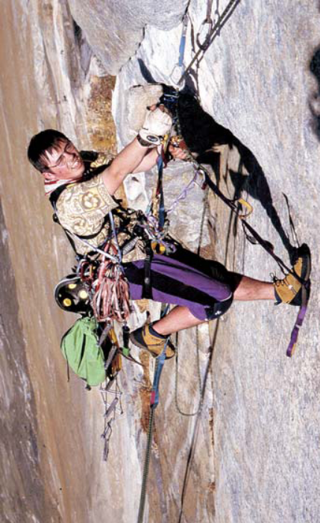

Figure 11.1 Andy Kirkpatrick on Iron Hawk, Yosemite Valley
Photo: Andy Perkins

There are two basic types on the market today:

Adjustable size
Harnesses with adjustable leg loops enable changes in size to accommodate extra clothing and achieve a precise fit and will also allow you to don the harness without having to step through the leg loops. These are all major advantages when winter climbing or mountaineering, although of course the harness may still be used for regular rock climbing.

Fixed size
These harnesses are adjustable only at the waist, are lighter, more compact and quicker to don than the above, making them ideal for general rock climbing.

Relevant standards

The European standard for all types of climbing harnesses is EN 12277. It specifies suitable materials for use in harnesses and defines methods of test and performance criteria. The main requirement is a strength test designed to simulate the load placed on a harness in the event of a fall. The forces involved in the test deliberately greatly exceed any forces, which could occur in a fall, and harnesses have never been known to fail due to a lack of strength. Meeting the standard does not guarantee a harness will be comfortable. Comfort is a very individual thing, and it is recommended that the purchaser should spend some time wearing a harness, and
hanging in it in the shop. The best-padded harness may not be the most comfortable to hang in.

Observed faults and failures

The most common problems with harnesses seen by the BMC Technical Committee relate to buckle slippage. These instances arise either when the manufacturer’s instructions are not properly followed and the buckle is mis-threaded, or when a design flaw allows slippage in a properly threaded buckle. Some manufacturers have reported problems with corroded buckles after immersion in seawater, but this could be avoided by thorough cleaning of the harness soon after immersion.

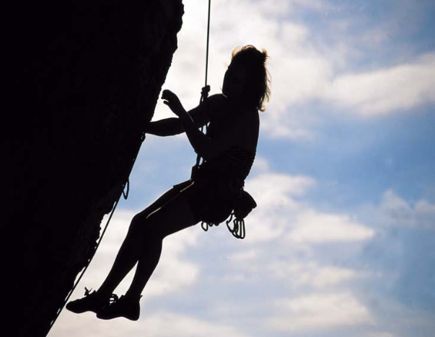
Figure 11.2 Check your harness buckle frequently for slippage (Anne Arran, Calanques)
Photo: Alex Messenger

There have also been instances where people have mistakenly clipped into gear loops instead of the main tie-in point, and also where climbers have failed to tie in correctly, but these cases are due to user error, and do not involve actual failure of a harness within the defined standards.

One report from Germany details dangerous abrasion damage to the tie-in loop of a harness, which was assumed to have been caused by continued rubbing of the rope against the harness during repeated falls. This problem has been observed in the UK, but only in the most extreme cases. It generally happens when long periods of hanging in the harness are combined with a dirty or gritty environment, leading to repeated abrasion of the harness material (eg when cleaning routes). Be aware of this potential situation if you do a lot of sport climbing and working of routes.

How to prevent failure in use

Always use the harness in strict accordance with the manufacturer’s instructions, particularly with regard to threading the buckle and ensuring there is enough webbing left over to be safe (usually 50–75mm). Do not use the gear loops for any other purpose than carrying gear – they are not strong enough! – and try to avoid general abrasion when climbing or sitting down whilst wearing the harness. Be aware that gradual buckle slippage can occur in some harnesses, but that in general this is too slow to be of concern in general rock climbing situations. However, if the harness is to be worn for long periods, regular checks of the buckle should be made (Figure 11.3). Any slippage is accelerated by oading and unloading, for example whilst jumaring.

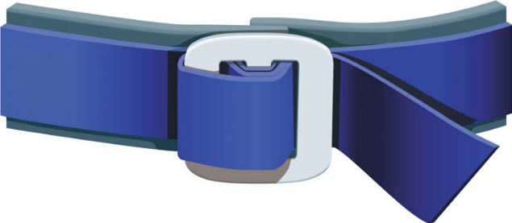

Figure 11.3 Harness buckle threaded correctly

Routine care and maintenance

There is no doubt that careful use can avoid many potential problems. An important part of this is regular examination of the key parts of the harness, including all tape sections, stitched joints, buckles and other adjusting devices:
• Tapes
Look for excessive fading, wear or cuts (Figure 11.4). Any of these could mean that the harness should be retired.
• Stitched joints
Look for damaged, frayed or broken stitching as can occur if the harness becomes abraded (eg.scraped over rocks). Never attempt to re-sew a damaged section of stitching; retire the harness immediately.
• Abrasion at tie-on points
Look for signs of abrasion, fraying, etc, where the abseil loop touches the rest of the harness, or where the rope is tied on to the harness.
• Buckles and adjusting devices
Look for bending that could affect the operation of the buckle or adjusting device. Also, make regular checks for corrosion, especially if using the harness in a saltwater environment.
49

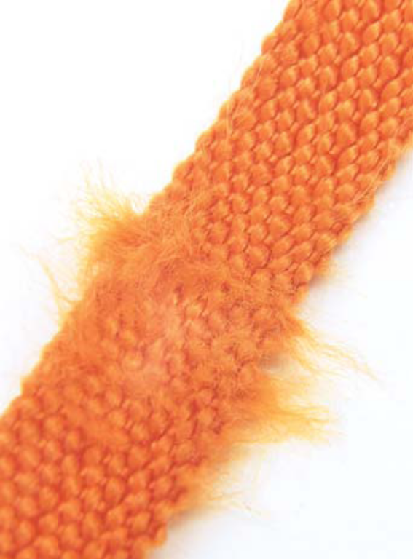
TEXTILE EQUIPMENT
51
• If the harness gets covered in saltwater or seaspray, rinse it thoroughly in cold tap water
as soon as possible, paying particular attention to the buckles. Then allow it to dry naturally.
• Avoid getting the harness covered in dust, grit or sand, as this can be ground into the webbing
structure during normal use and may cause invisible weakening. The harness should be cleaned as above if this occurs.
• Store the harness in a cool dark place, and keep it away from acids, sharp edges and high
temperatures. Storing the harness in the bag provided by the manufacturer will help keep it clean inside your rucksack.

Degradation and discard criteria

If an examination as detailed above reveals cuts, tears or serious abrasions in the webbing, buckles or adjusting devices appear damaged, then you should seriously consider discarding the harness straight away. If in doubt, compare your harness with a new one in a shop, or contact the manufacturer for advice – for a small charge they may be willing to assess its condition for you. Current advice from most manufacturers is that a harness has a maximum shelf life of around 10 years. With average use, (weekends, once during the week and a couple of holidays per year) a harness should generally last for 5 years, although as with ropes, this could be as little as a few months, or even a single use in extreme cases.

