UIAA STANDARD 153 / CRAMPONS
Recommendations for Inspection and Retirement

Foreword

The UIAA equipment standard provides a baseline for equipment performance in a test lab under controlled conditions on new equipment. Although these test conditions are relevant to the conditions encountered climbing, conditions encountered at the crags and the condition of the equipment are equally important. This recommendation from the UIAA member federation The British Mountaineering Council (BMC) provides vital equipment information that is NOT explicitly addressed in the standard, particularly failure modes of the equipment and recommendations for the use, inspection, maintenance, and retirement of equipment.

These recommendations are of necessity general. For any specific piece of equipment, the primary source for all equipment information is the manufacturer. Always read and heed the manufacturer’s warnings and instructions for use, inspection, maintenance, and retirement of equipment. Taken together, the UIAA standard, the BMC recommendations, and the manufacturer’s instructions provide a sound basis for understanding climbing equipment and its limitations. This understanding, in conjunction with best practices, is the basis for managing the risk associated with climbing and the use of climbing equipment.

THE FOLLOWING INFORMATION ON USE, CARE AND MAINTENANCE COMES FROM THE BMC BOOKLET: CARE and MAINTENANCE
Copyright © 2001 British Mountaineering Council
Cf. http://www.thebmc.co.uk/Feature.aspx?id=1170

CRAMPONS
By Alan Huyton
a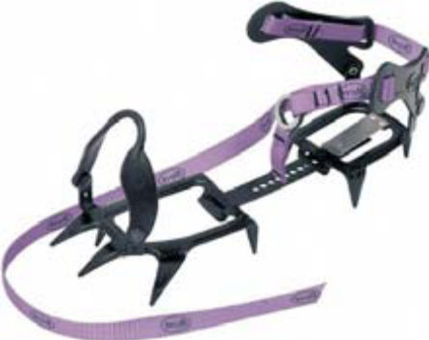b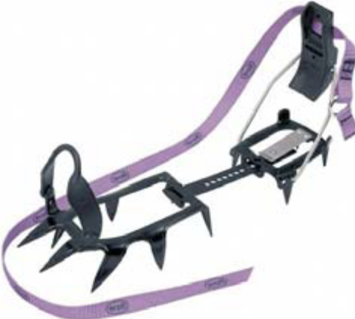

c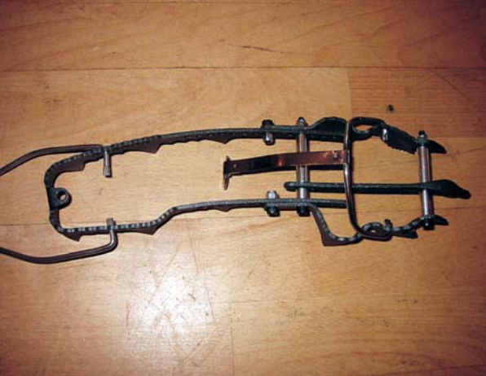

Figure 2.1 Different types of crampon: a – Walking Crampon, b – General Mountaineering Crampon & c – Technical Climbing
Crampon Photos: DMM/Ben Lyon

Introduction

Hunters in the European Alps used a simple type of heel crampon as early as the sixteenth century, but the first mountaineers preferred to use their nailed boots alone. Whymper wrote that he only felt comfortable wearing crampons where there was no possibility of slipping – and he would not use them on an ice slope for any consideration whatever! It was not until the twentieth century that this opinion changed but crampons then quickly became standard issue for serious alpinists. In 1932 the 12-point crampon was introduced and over time this revolutionised snow and ice climbing, the forward facing front points allowing climbers to ascend very steep ice with reasonable security (Figure 2.1a). Since then improvements in strength and design have made crampons lighter, stronger and more suited to different types of climbing such that they are now an essential part of any winter climber’s or mountaineer’s equipment.

a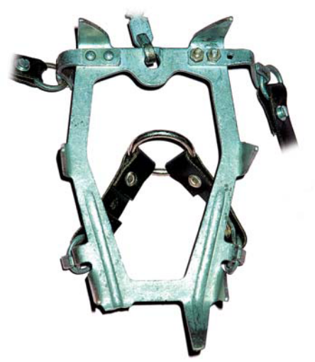 b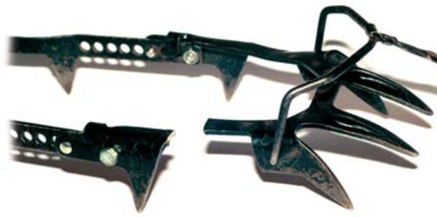

Figure 2.2 Damage to crampons caused by a – brittle failure b – fatigue

Relevant standards

The European Standard for crampons is EN 893. This specifies safety requirements and test methods for crampons for use in mountaineering on snow and ice including climbing mixed terrain. For the purpose of the standard a crampon is defined as a device fitted with spikes, which covers the sole and heel of a boot so as to provide grip on snow, ice and mixed terrain and which has a system of attachment to the boot. The standard does not cover instep crampons.

The standard gives requirements for the shape and design of crampons. The main ones are that each crampon must have an effective system of attachment to the boot and have at least eight spikes, six of which should point downward. Also included are various requirements for the strength of the crampon. These include the hardness of the metal, the strength of the spikes, frame, attachments and other parts. Detailed test procedures are then given by which these properties are to be measured.

It is worth noting that the strengths specified for the various parts have been decided as reasonable values for normal use and that crampons meeting the standard may fail if subjected to high or abnormal loads. It would be a mistake to assume that just because a crampon is made to the standard it will never break.

Observed faults and failures

In the period from 1985 to 1999 the BMC Technical Committee has investigated 31 incidents involving broken crampons. In four cases the attachment system failed whilst in the remainder the actual crampon itself broke. All the incidents can be attributed to one or more of the following:

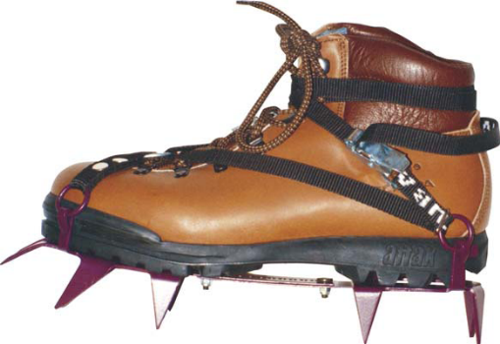
Figure 2.3 A well-fitting crampon Photo: BMC Collection

• Brittle fracture or fatigue (19 cases) Crampons take an incredible amount of punishment – a climber carrying a heavy rucksack and walking over rock or boulders transfers a large force onto the points of the crampon. (For the technically minded the impact force can be around 3kN, which on rough terrain might be shared by only two or three of the points!). Also the crampon bends slightly, even on the stiffest boot, and this happens on every step.
On a ten-mile walk a crampon could experience 10,000 bending cycles. Metal will break if cold enough and either bent with sufficient force (brittle fracture) or flexed back and forward enough times (fatigue failure).The surprising thing is not that some crampons break but rather that most crampons don’t break – a testament to our equipment manufacturers – see Figure 2.2.

• Poor fitting of crampon to boot
It would be unreasonable to expect that all crampons will fit all boots, so a number of the failures were due to inappropriate boot/crampon combination leading to the crampon becoming detached. It is essential to take your boots to the shop when buying a pair of crampons to ensure that they are compatible and fit together properly. Advice on choosing the correct type of crampon for your boots and intended use can be found in the BMC companion booklet on crampons and also in various books and magazine articles covering equipment.

• Poor design or manufacture
The remaining failures were due either to poor design or manufacturing defects. The design problems have been identified and these models have either been withdrawn or modified. The manufacturing faults have tended to be isolated incidents that were reported back to the manufacturer.

How to prevent failure in use

There is no sure method to avoid crampon failure. By the very nature of the treatment given to crampons it is possible they may break eventually. However there are some simple guidelines you can follow to reduce the likelihood of a failure:

i) Choose a crampon suitable for your boot type – putting fully rigid crampons on flexible boots may damage the boots, the crampons and possibly your feet into the bargain.
ii) Choose a crampon appropriate for your intended use – using highly technical crampons for walking on mixed terrain will increase the likelihood of fatigue failure. Similarly, using crampons with long front points for climbing on rock will probably result in broken front points very quickly!
iii) Regular inspection – be aware that your crampons take the most abuse of any of your mountaineering equipment so be extra vigilant with frequent inspections as below.

Routine care and maintenance

Crampons require very little maintenance to keep them in working order but they should be inspected before every use for signs of damage and wear. The following procedures are recommended:
• Clean off any mud and remove any small stones from the hinge (on hinged crampons).
• Carefully examine the corners where the points join the frame for any signs of cracks. A magnifying glass will be useful for this. Discard the crampons if any cracks are visible.
• Check for loose nuts on the adjustment bars and tighten if necessary. A glue such as Loctite may be useful if the nuts frequently work loose.
• Check the straps for damage. Neoprene straps will tend to fray along the edges but passing a flame along the edge to melt the loose fibres can easily rectify this.
• Check the rivets in the straps (if applicable) and insert new ones if they become loose or damaged.
• The heel lever on step-in crampons should move freely, if not a spot of oil may help.
• When sharpening the crampons, sharpen the front points on the top like a chisel so that the cutting edge is at the bottom. Downward points should be sharpened along their narrow edges, not their sides. Sharpen with a hand file as a power tool can heat the metal too much and ruin its temper. Remember that points do not need to be razor sharp!
• Finally, it is well worth getting a crampon bag or a set of rubber spike protectors – these help to prevent damage to your rucksack and its contents by the spikes. After use the crampons should be wiped dry and stored in a warm, dry place. Do not store crampons in the rubber protectors or crampon bag if there is any chance of dampness or condensation.

Degradation and discard criteria

Degradation is not a problem with crampons – if looked after properly there is no reason why a pair should not last 15 to 20 years of normal use. It is much more likely that crampons will need discarding after some sort of damage or breakage and the criteria for this have been discussed above.

